TRACKBOT
Table of Contents

1. Dashboard

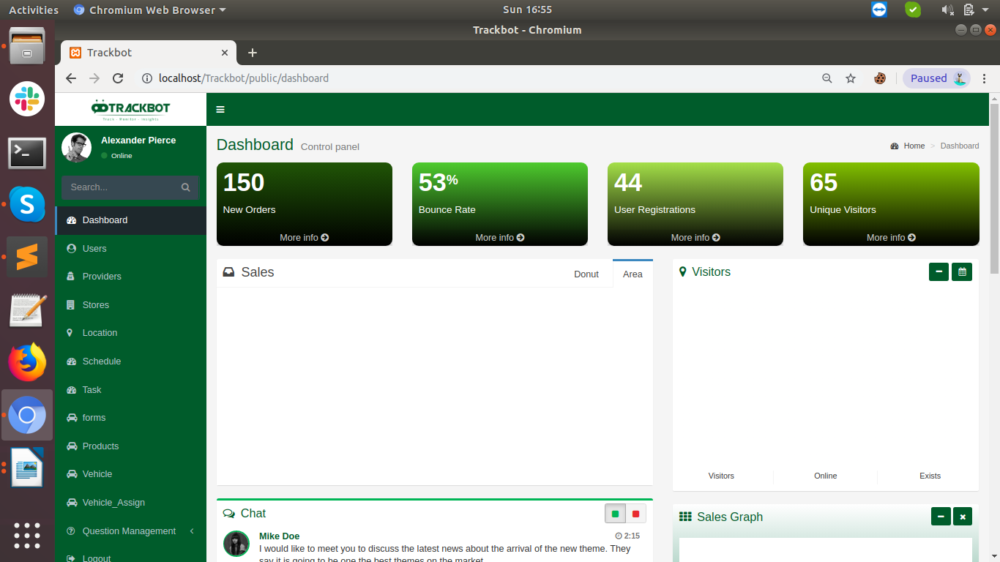

The dashboard section shows the information regarding:

1) Assigned Tasks , Schedule , Locations to the the Sales Rep.
2) Sales Rep Information.

Locations :

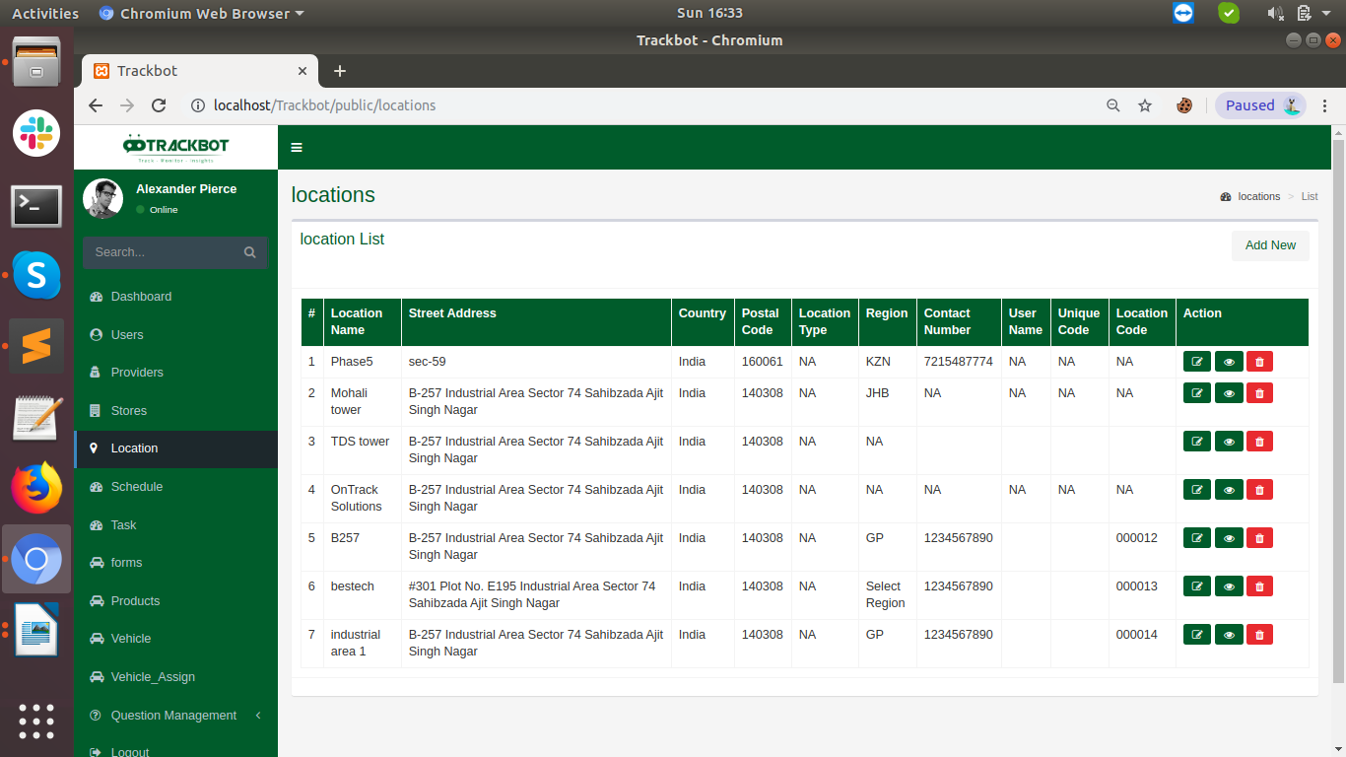

Location modules shows assigned locations to sales rap.

Add Locations:

Add Location Form – To add the locations where Sales representatives require to visit. This form can add the new locations to the Sales Rep by clicking on the Add new Form From the location’s index page.

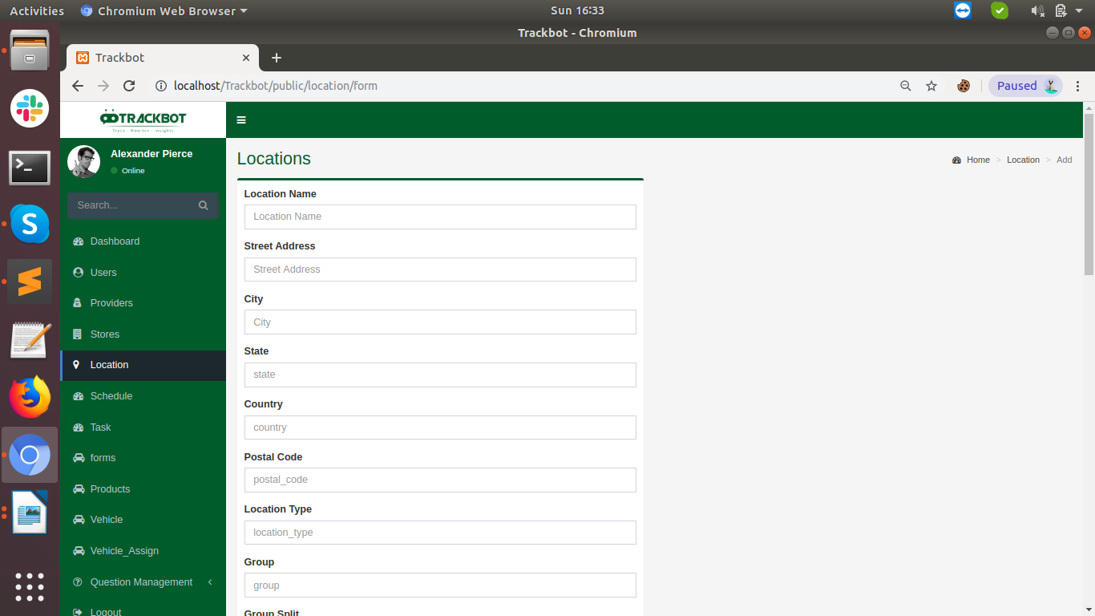

Edit Location :

To edit the added location . By clicking on the edit icon, a form will open where you can edit the location information.

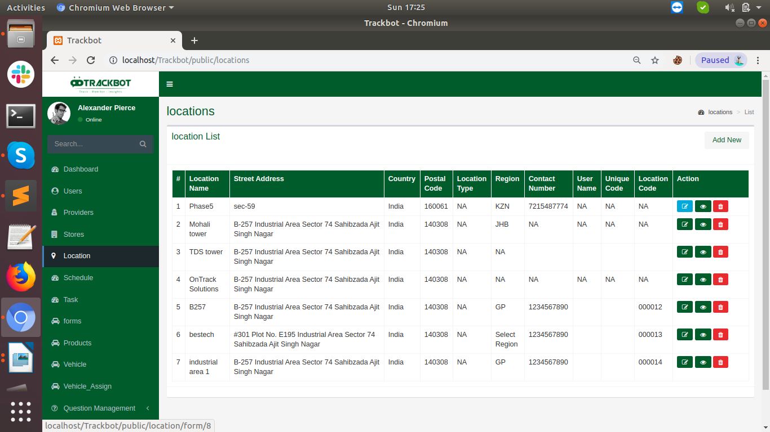

Show Locations :

Once click on the view icon admin can see the history of the particular assigned location
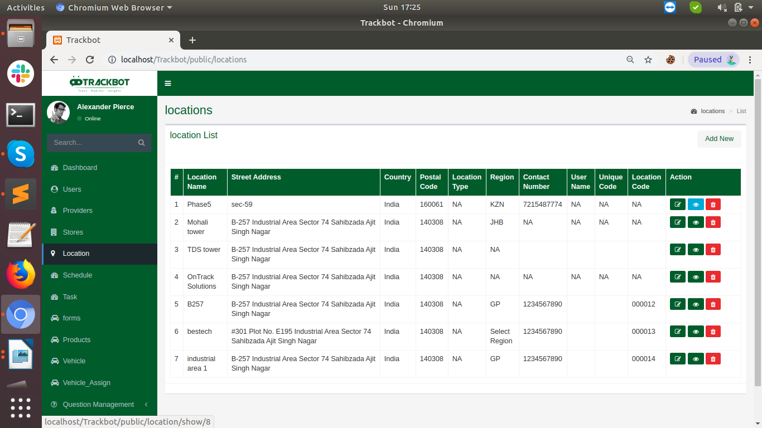
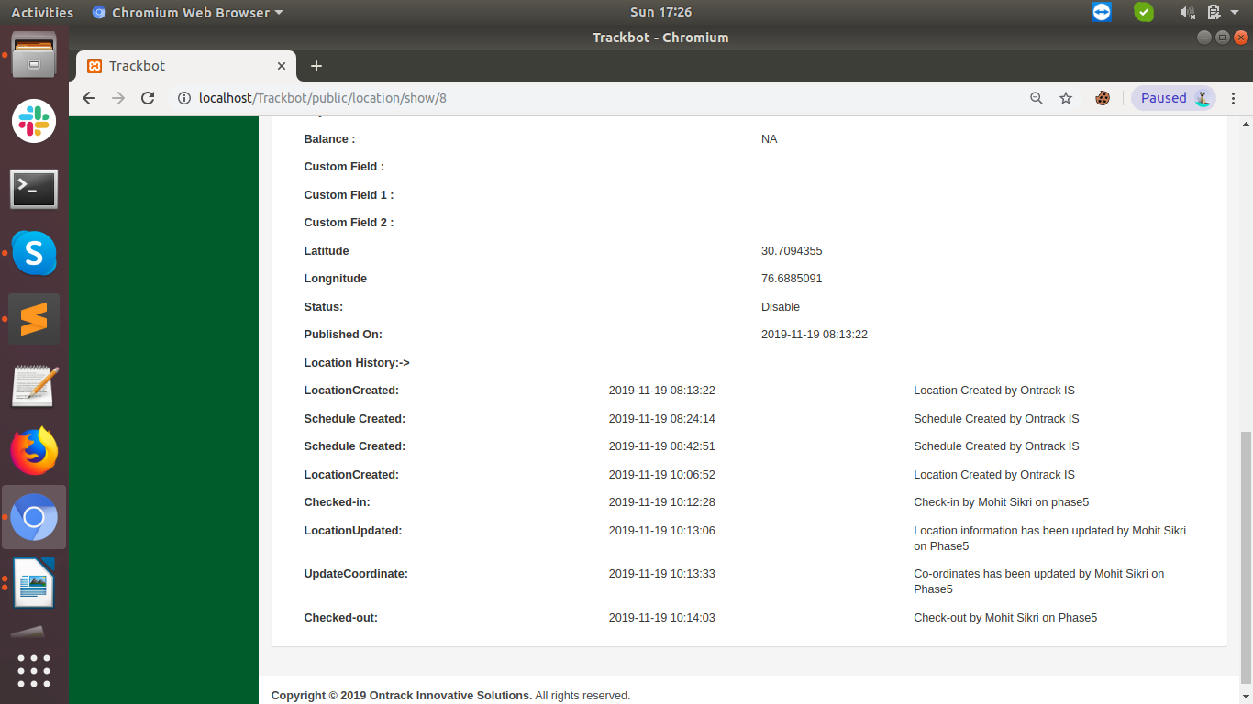

Delete Locations:
To delete the particluar location just click on the red delete icon.
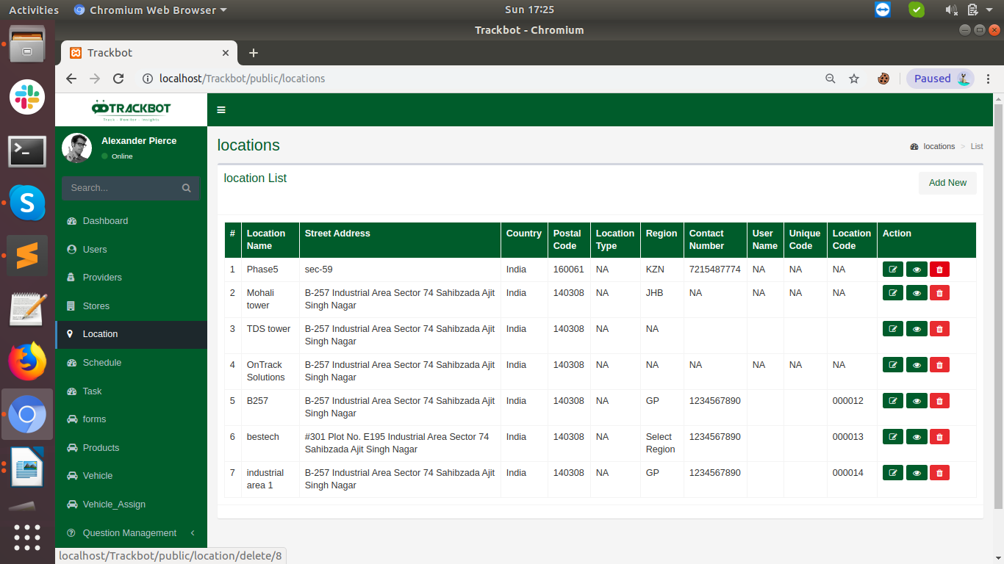
Schedule:

Schedule created the schedule on assigned locations.

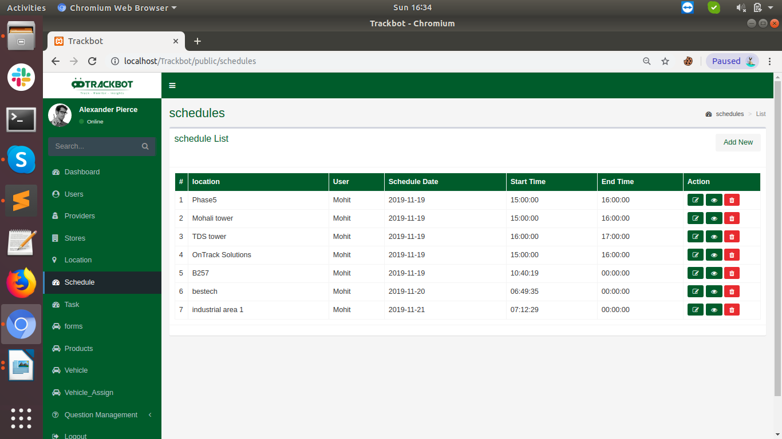
Add Schedule :

Below is the form to add Schedules for the assigned locations.
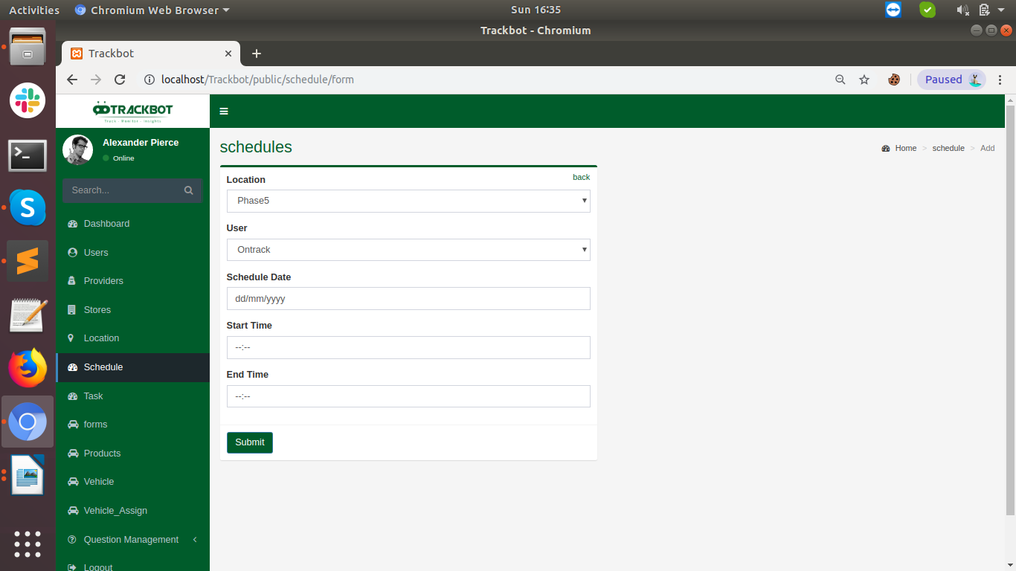
Input fields are such as:

1) Locations : A select box shows the all assigned locations to select one of them to create an schedule.
2) User : Select box with a list of all sales representatives to select to assign the schedule among them.
3) Schedule Date : Calender to select the date to create schedule.
4) Satrt Time : Schedule Start Timings.
5) End Time : Schedule End Timngs.

Edit Schedule:

To edit the added location . By clicking on the edit icon, a form will open where you can edit the schedule information.
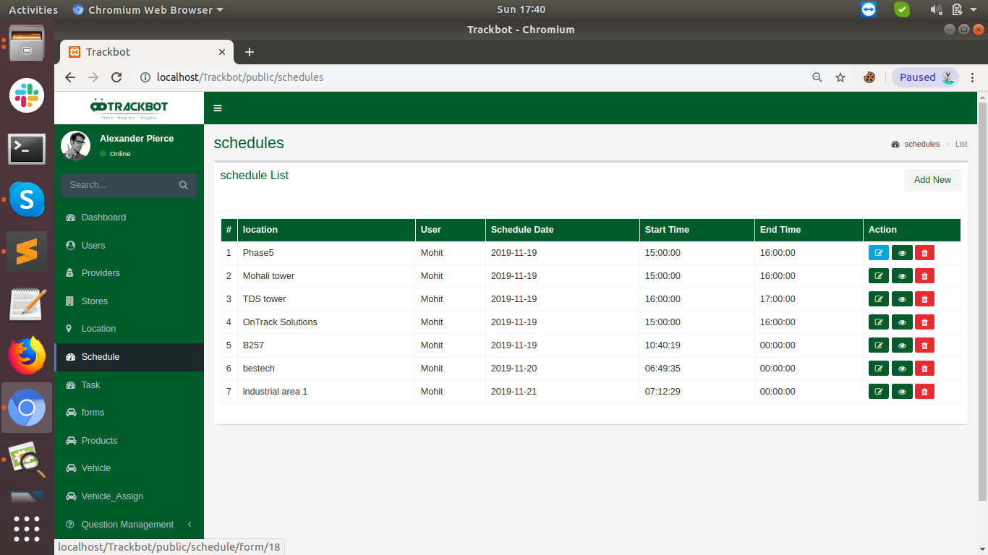
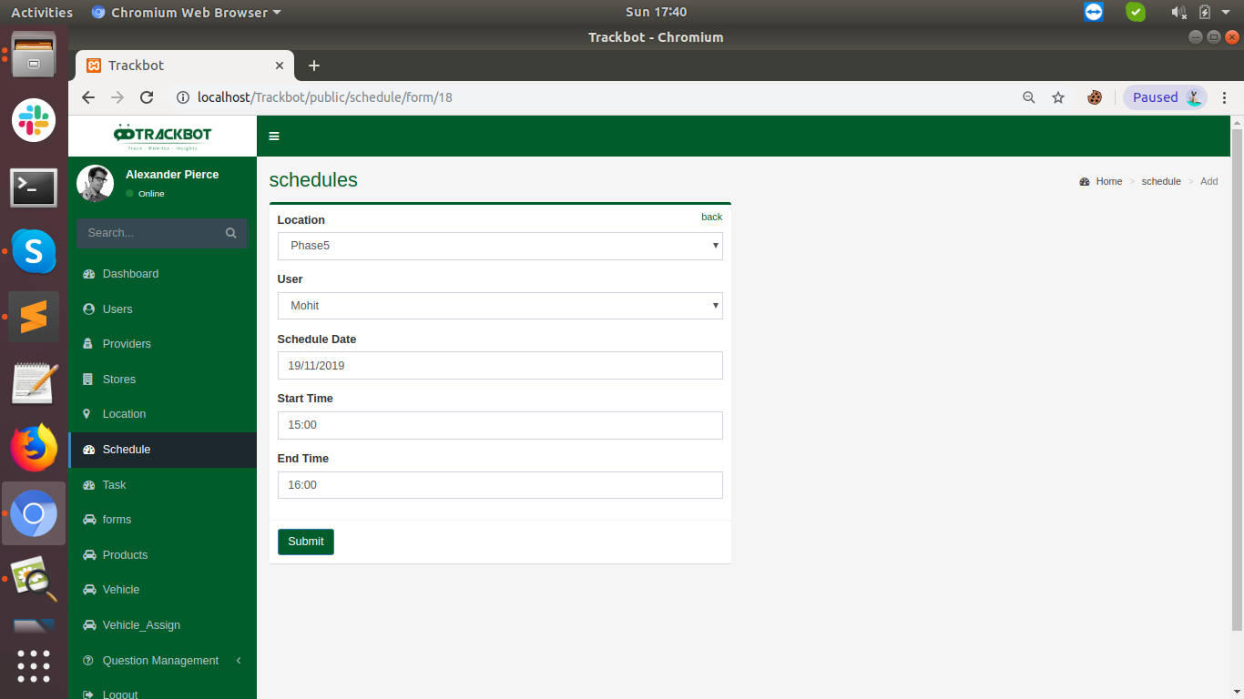
Show Schedule:

Once click on the view icon history on the partcular schedule is visible. History includes all filled inputs , when the schedules is created, on which location it is created for , check-in – check-out, update activities etc.

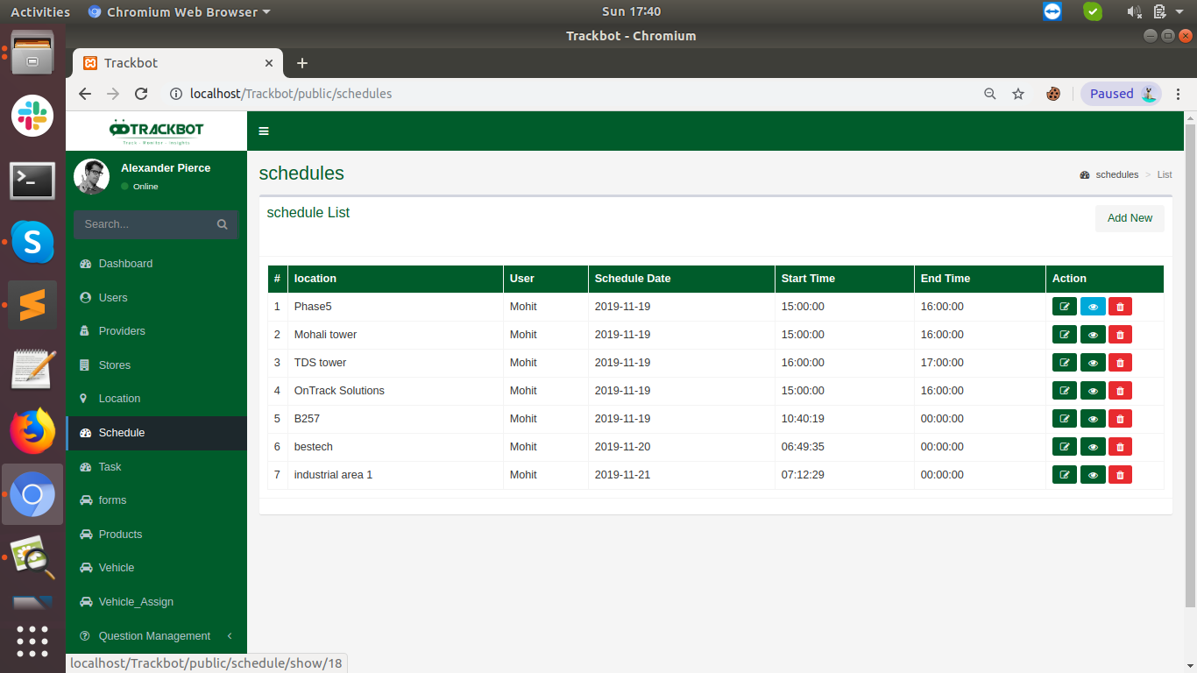
All information at show schedule look like this.

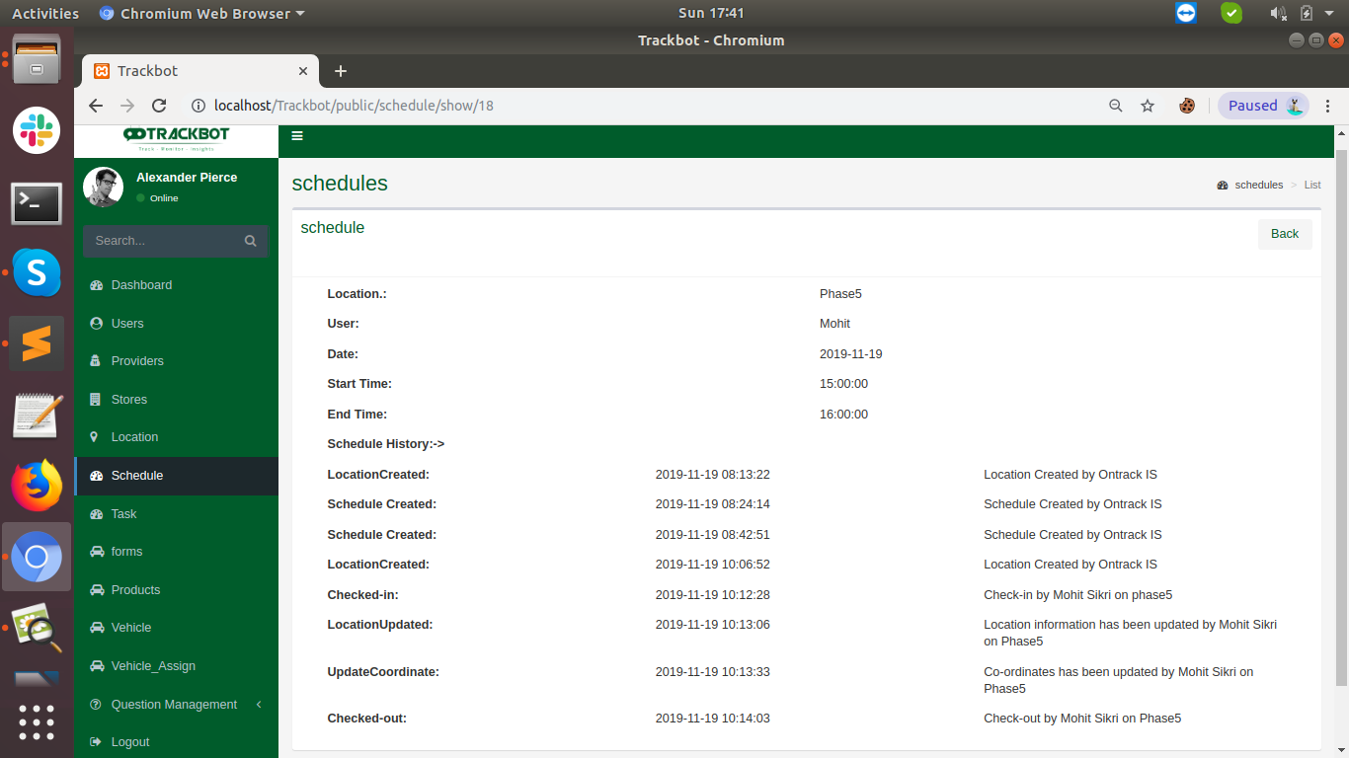

Task :

Add Task Form – To add the tasks where Sales representatives require to visit. Add can add the new locations to the Sales Rep by clicking on the Add new Form From the location’s index page.

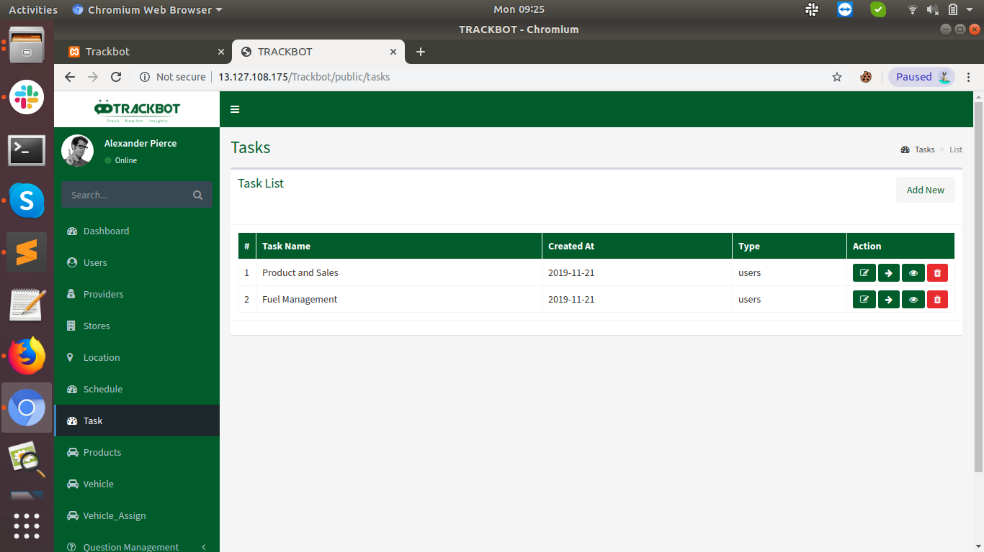

Input fields are such as:

1) Locations : A select box shows the all assigned locations to select one of them to create an schedule.
2) User : Select box with a list of all sales representatives to select to assign the schedule among them.
3) Schedule Date : Calender to select the date to create schedule.
4) Satrt Time : Schedule Start Timings.
5) End Time : Schedule End Timngs.

Edit Task:

To edit the added location . By clicking on the edit icon, a form will open where you can edit the schedule information.

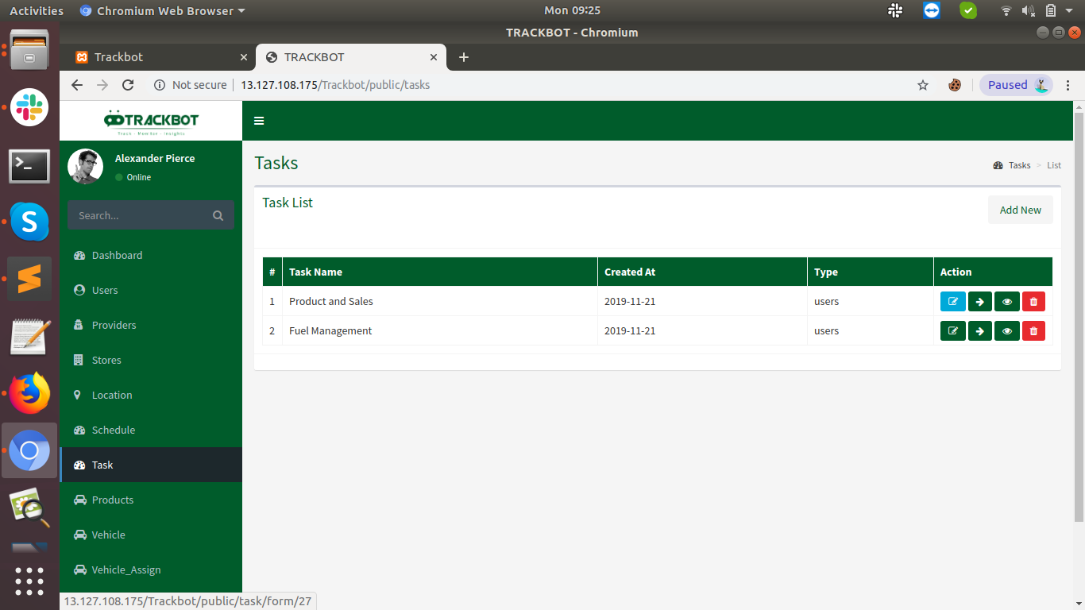
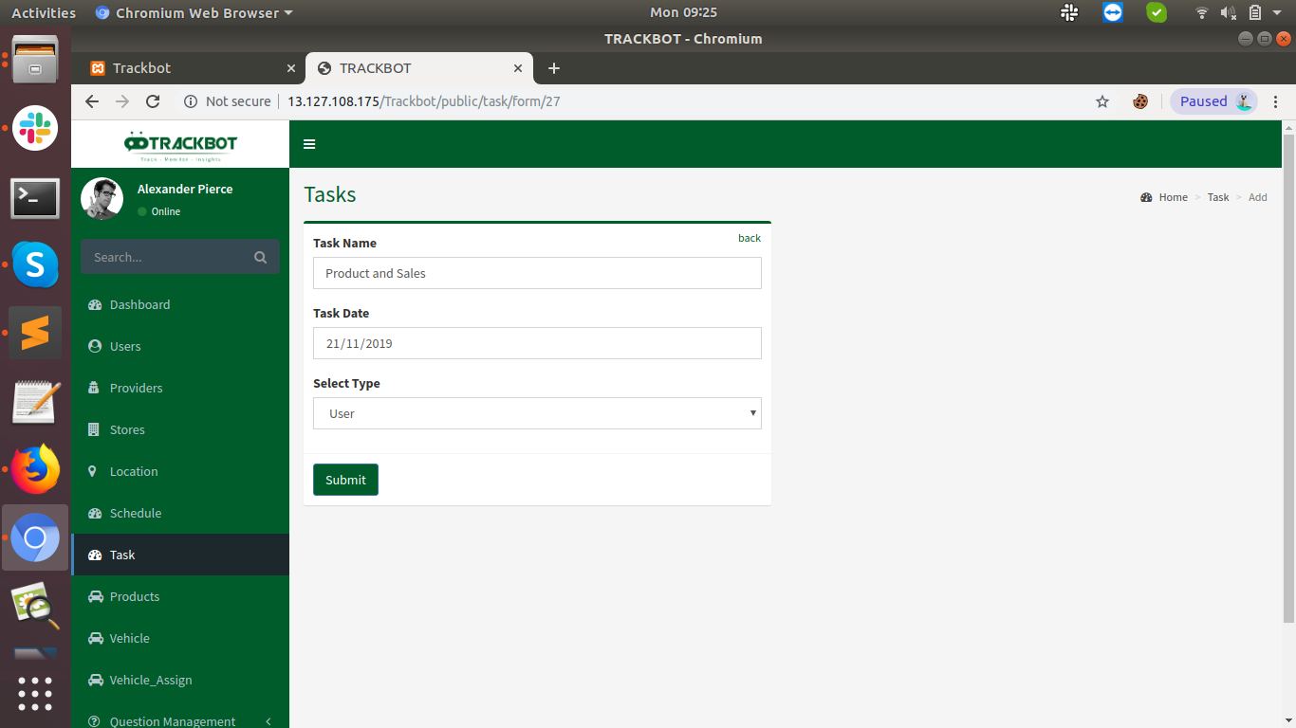
Show Task:

Once click on the view icon history on the partcular task and group is visible. History includes all filled inputs , when the schedules is created, on which location it is created for , check-in – check-out, update activities etc.

Group

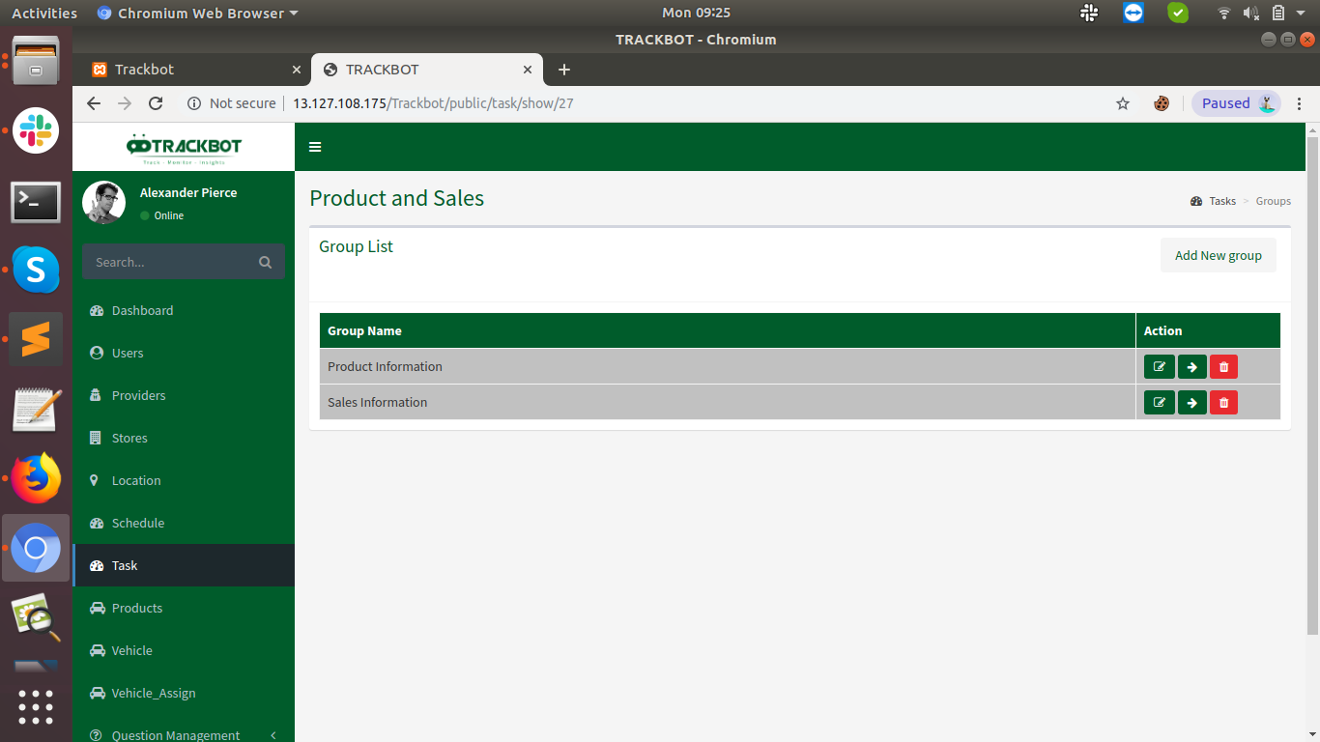
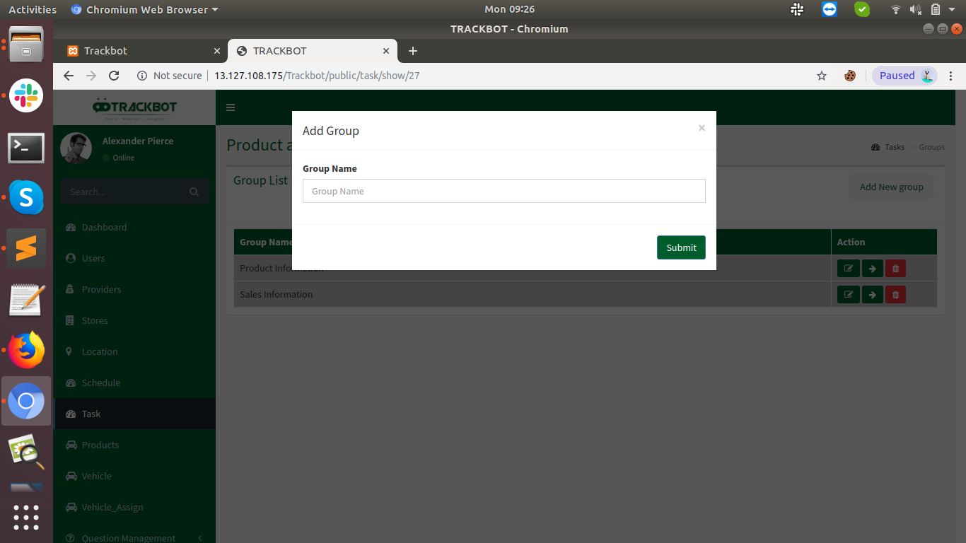
Edit Group

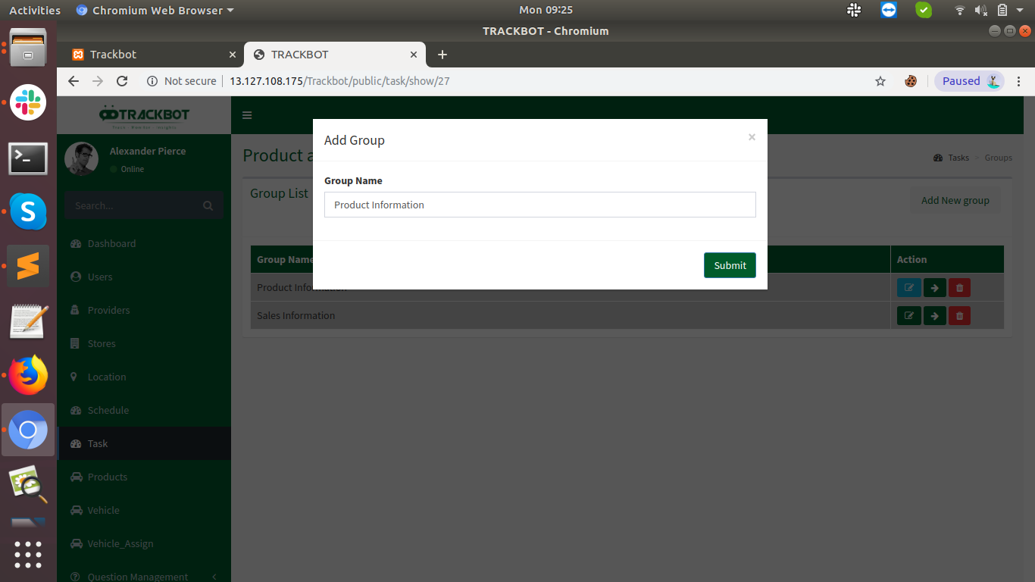

Questions Listing
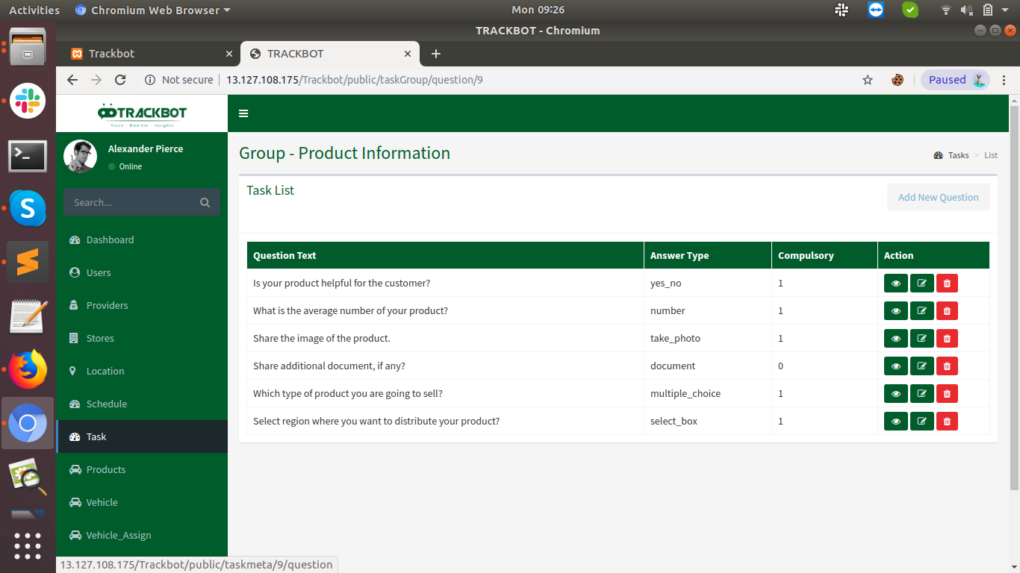

Show Question

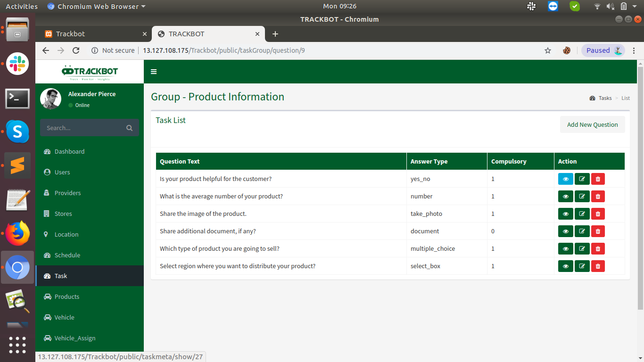
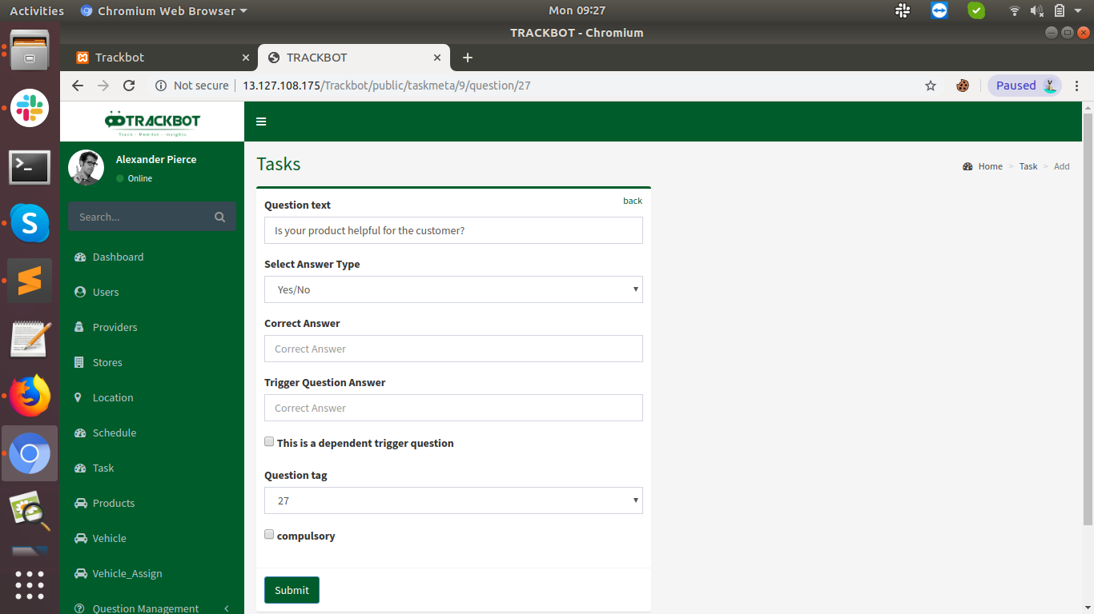
Edit Question

Delete Questions

